**FIT5225 Ass2 – Image Upload and Query Application**

**Task 3.4 UI Design & DEV**

This web-based application is built up within Amplify framework, which provides rich libraries for development, encompassing frond-end UI design and back-end configuration. As the key component, the Amplify Console facilitates our team to build, deploy, and host this could-powered application seamlessly.

The application includes four major functionalities, namely Log in, Sign up, Image Upload and Return Query. Considering the simplification and useability, last two functionalities are integrated into one page.

**Log in page**

The Log in page provides users with multiple options, Sign in Google and other email accounts.

Google account log in

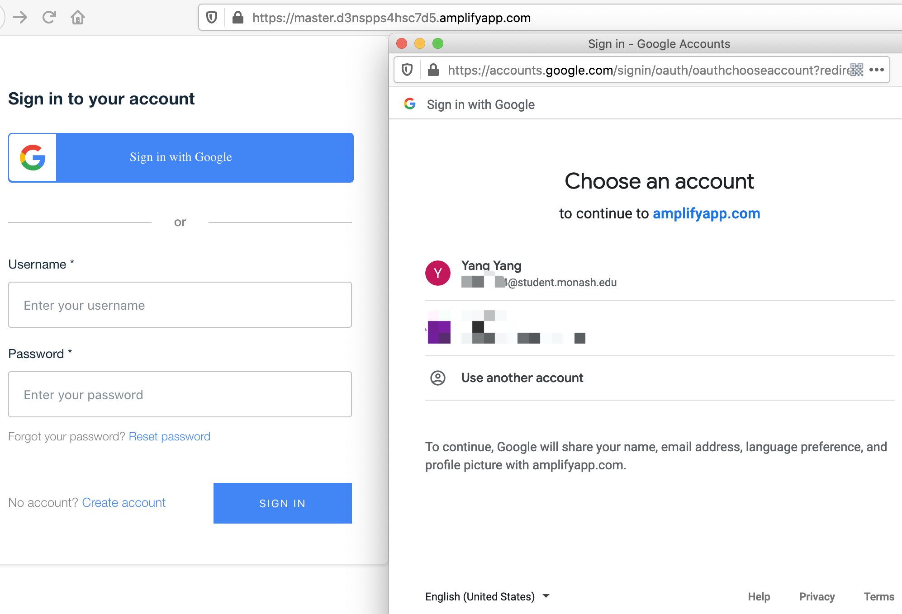

Front-end Design with basic verification, including username and password.

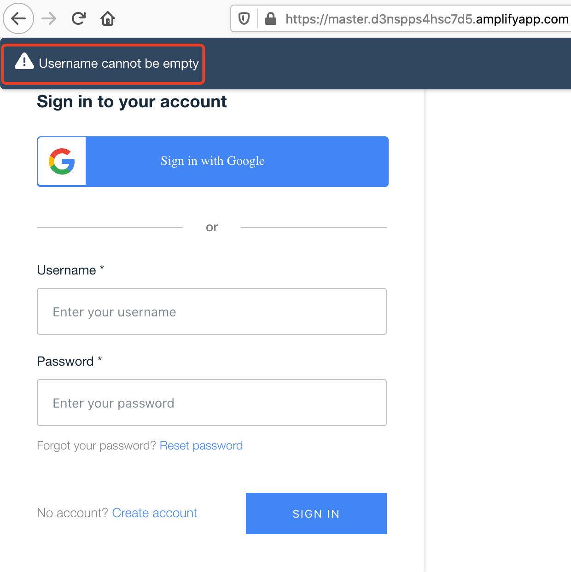 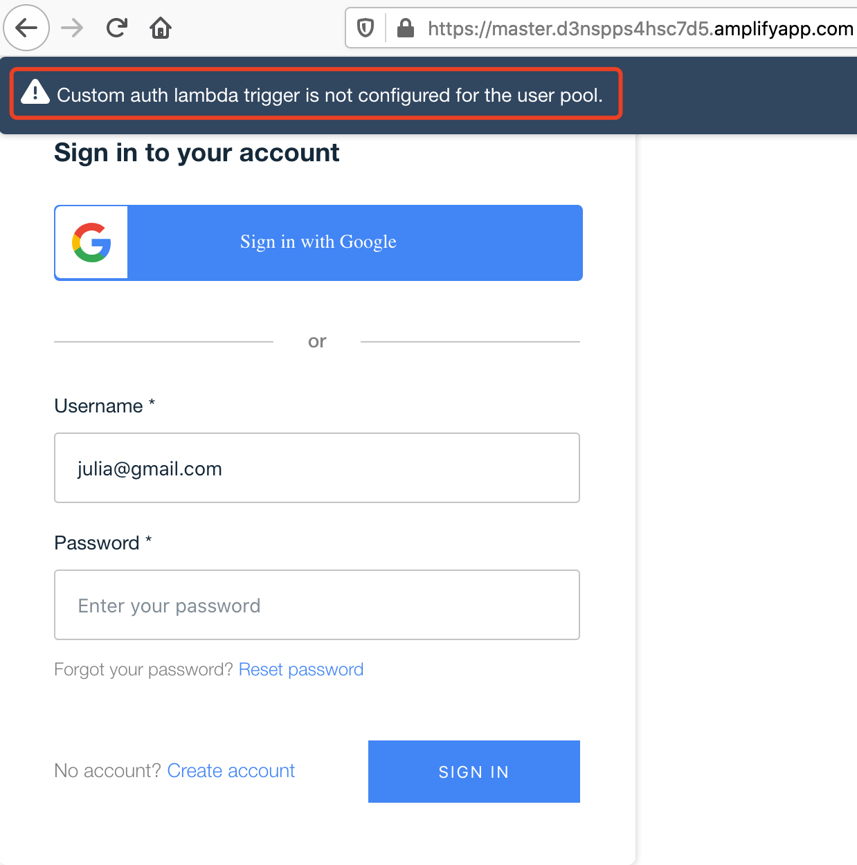

It offers reset password function which synchronizes one within AWS User Pool

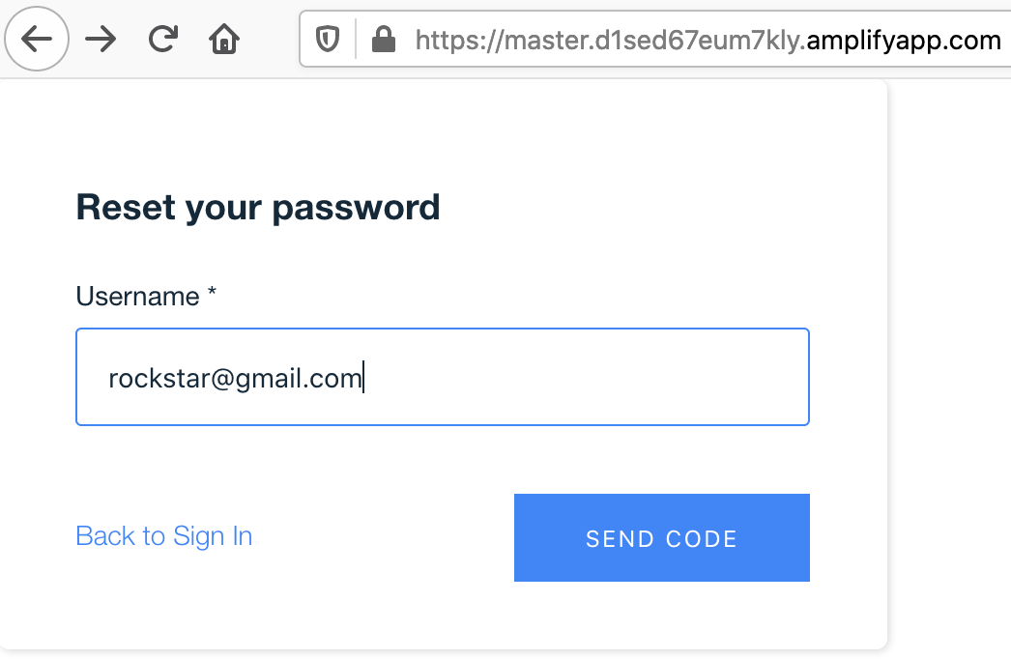 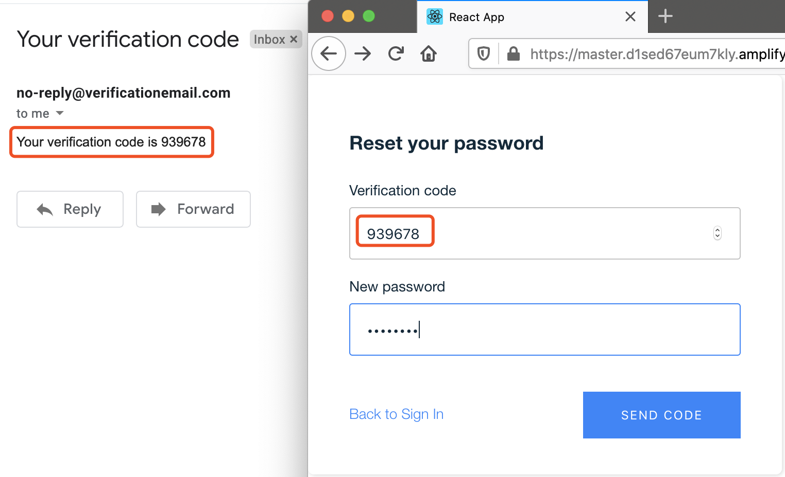

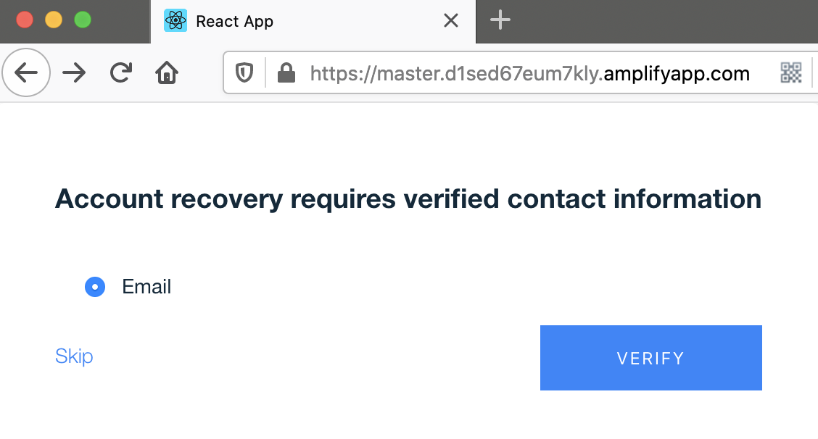

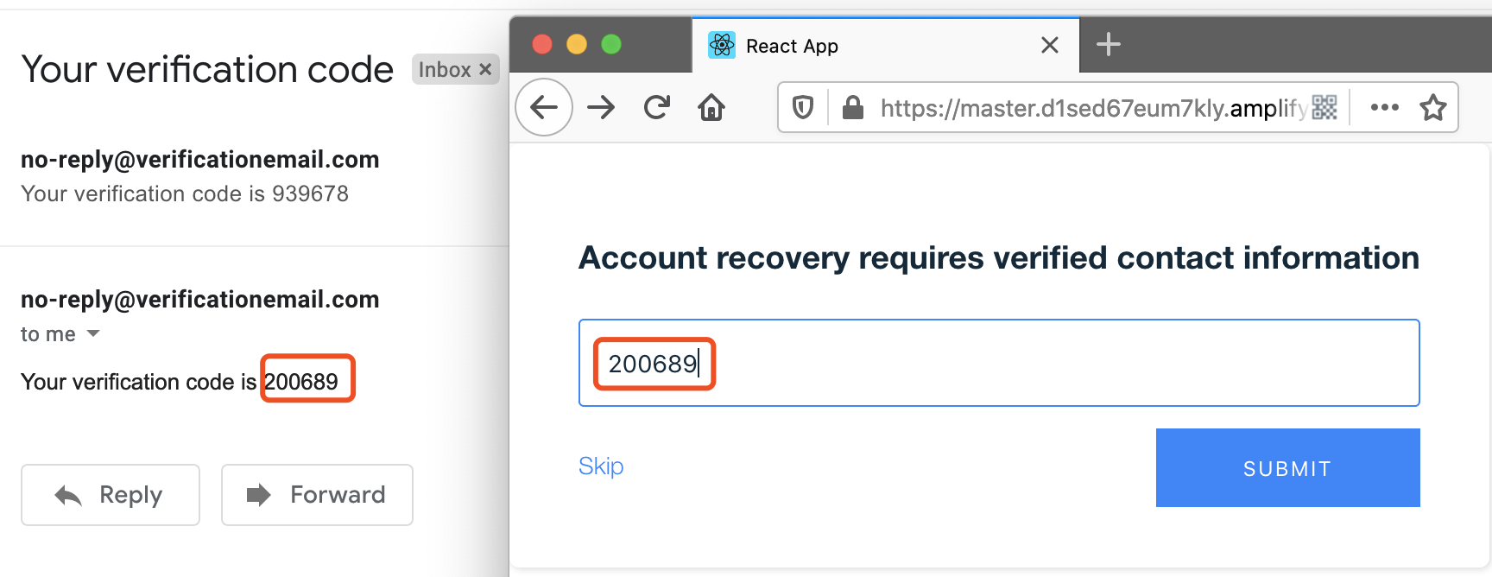

**Sign Up page**

The user can register a new account in this page. The information of following attributes are required: First name, Family name, Password and Email.

Moreover, password verification is configured in accordance with password complexity requirement of AWS User Pool

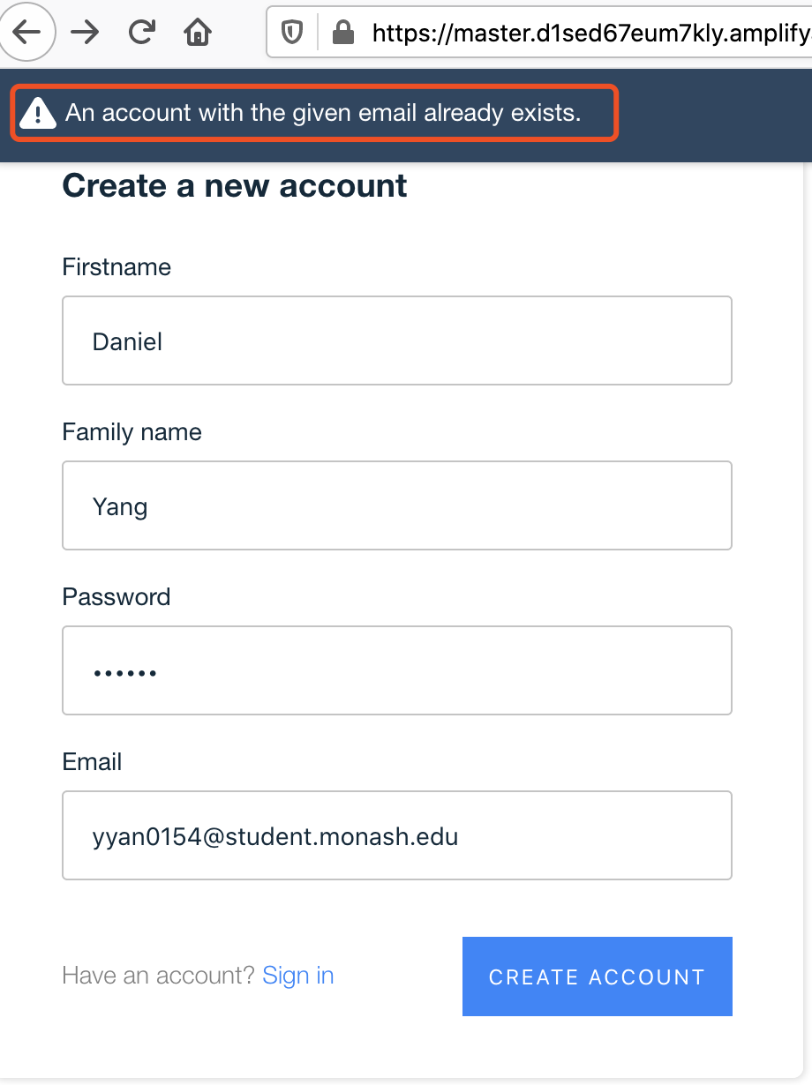 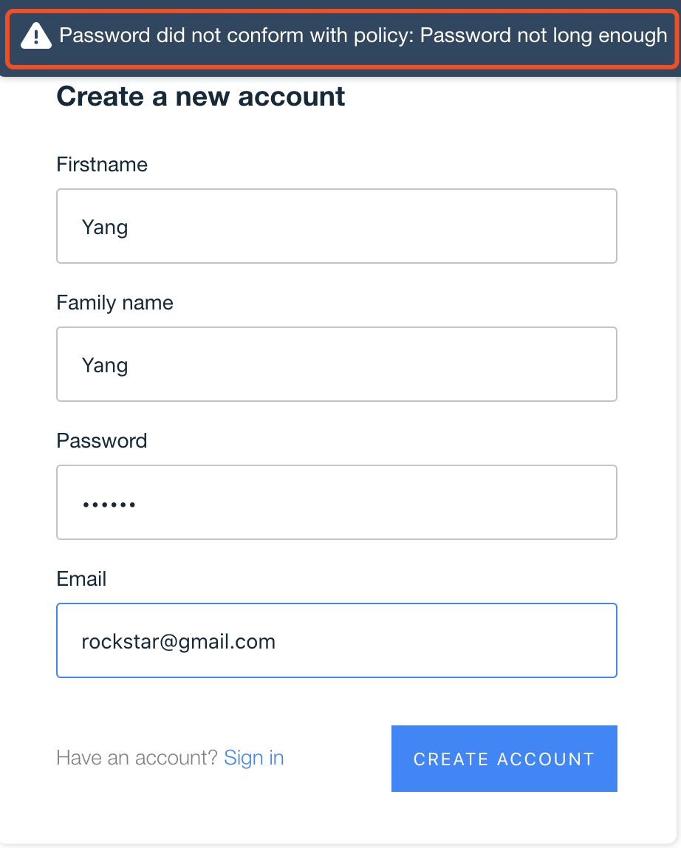 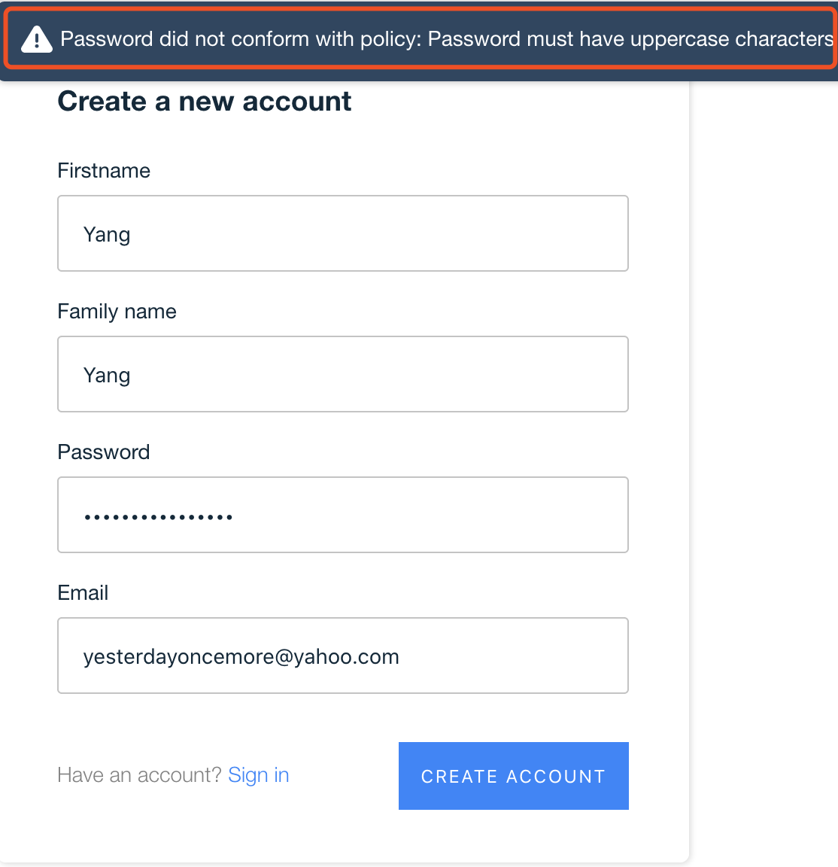

**Image Upload & Query page**

Users can redirect themselves to Image Upload page by clicking button ‘Click button to upload image’

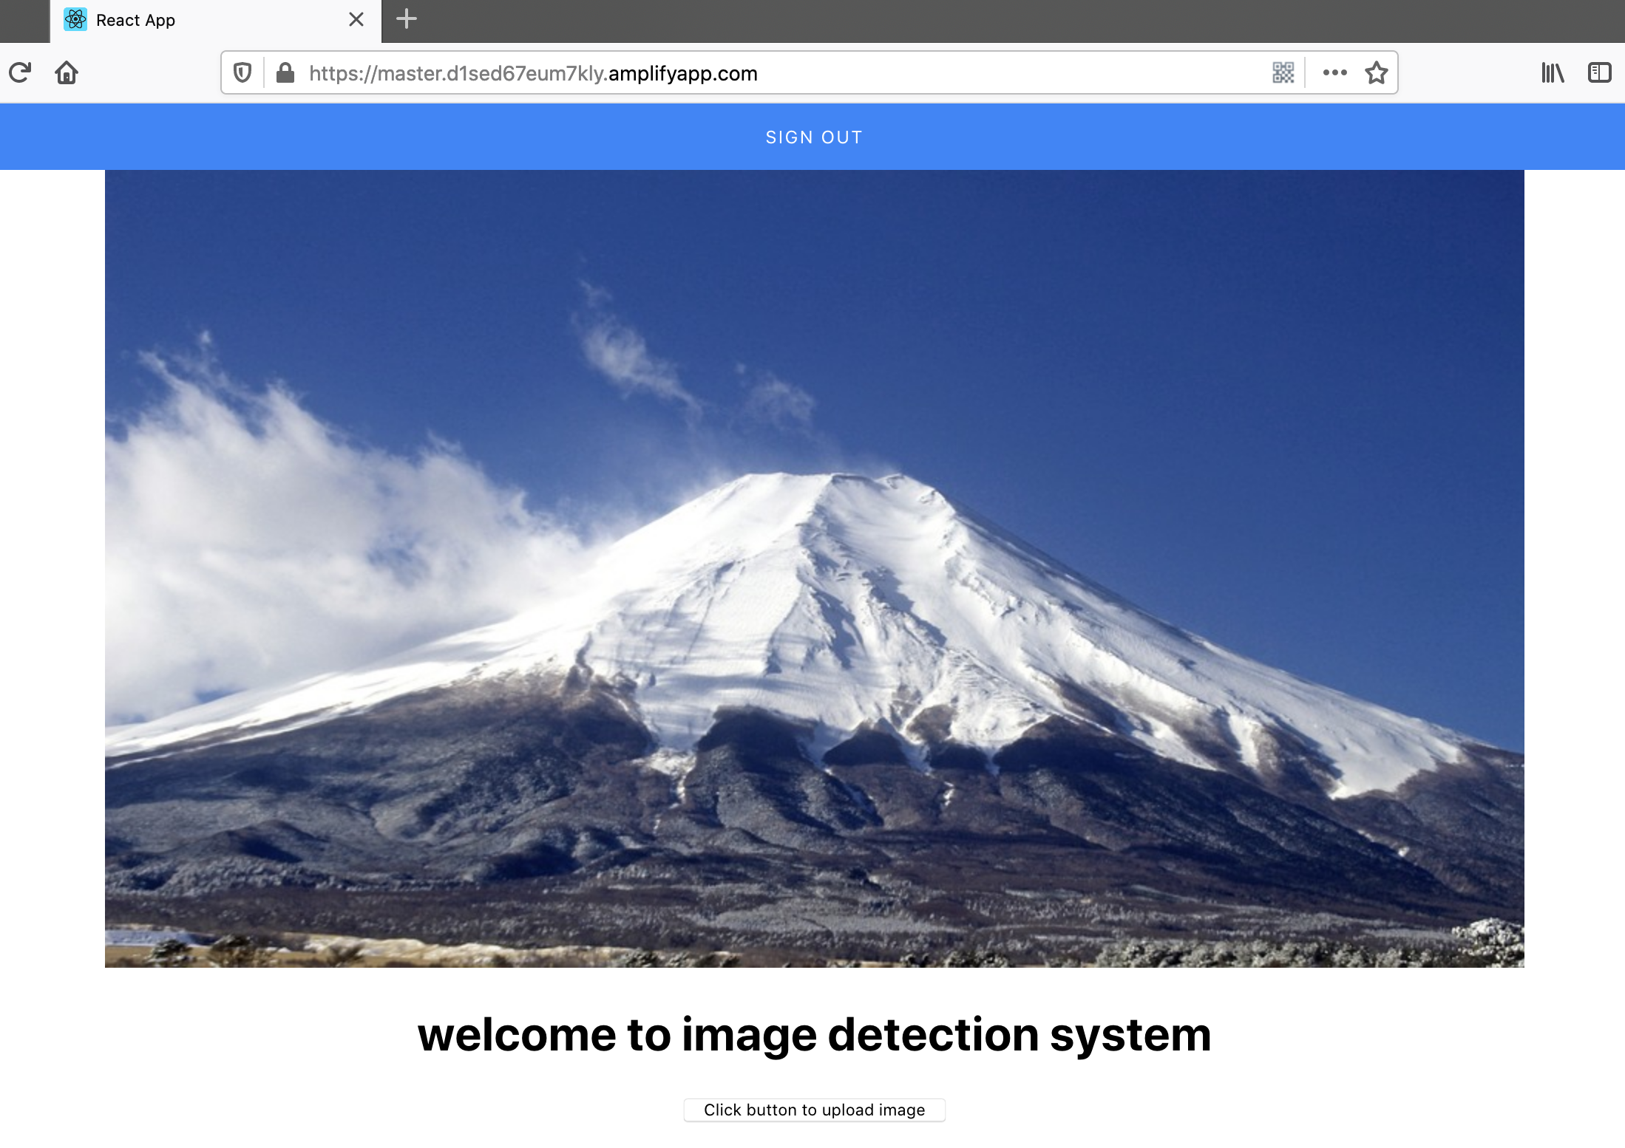

User upload image from this page to S3 by clicking button ‘Browser’ and then clicking ‘Save file’

Before loading image

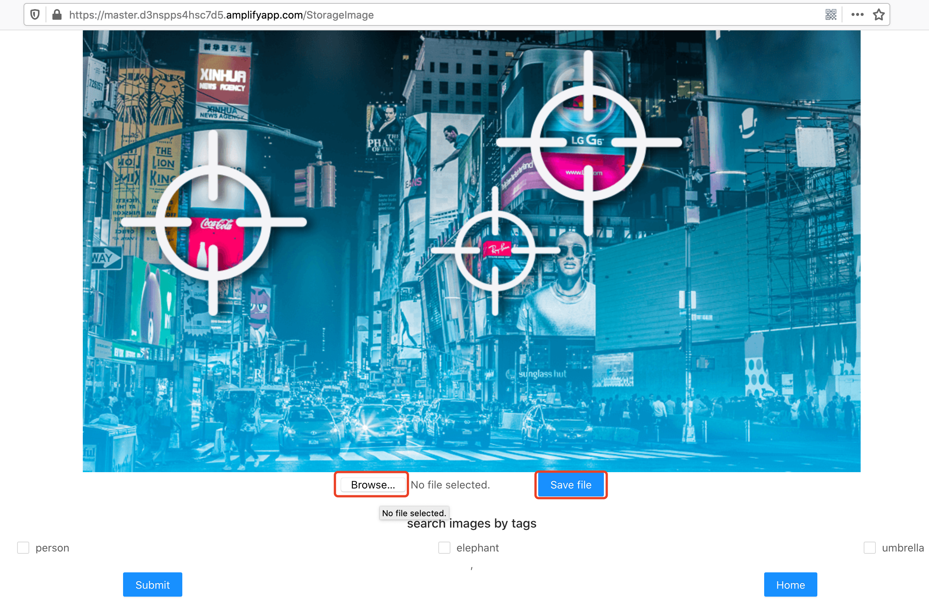

After image loaded

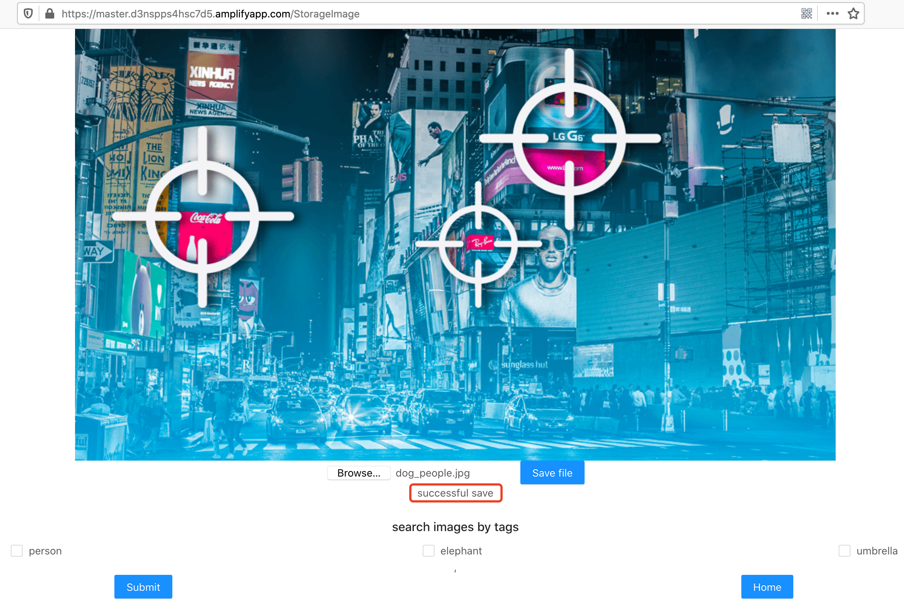

Once image is loaded to S3 bucket, users may query image they want by selecting the object category. Here three options are available: person, dog and box. Users feel free to tick and then click button ‘Submit’.

Eventually, the image containing the selected objects will be demonstrated on the screen.

This page redirects users back to Home page with clicking button ‘Home’.

